MEDIA RELEASE

The UIA and RIAI Launch the
‘Friendly and Inclusive Spaces’ Awards 2017

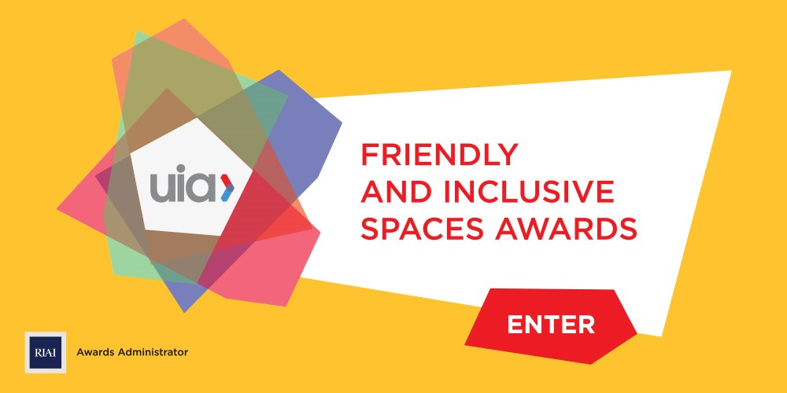

Paris and Dublin, 28 September 2016, The International Union of Architects (UIA) has launched the second edition of the ‘Friendly and Inclusive Spaces’ Awards. The Awards recognise and promote inclusive design – from buildings and public spaces to research – and are open to all architect members of UIA member sections. Entries can be submitted online, from 28 September until 20 December 2016, at https://uiafriendlyspaces.awardsplatform.com/.
The UIA Friendly and Inclusive Spaces Awards are being administrated by the Royal Institute of the Architects of Ireland (RIAI), based in Dublin. An international expert jury will short-list projects from around the world and the category winners will be announced the UIA World Congress in Seoul, South Korea, in September 2017.
Launching the Awards on behalf of the UIA, Irish architect Fionnuala Rogerson, Co-Director of the UIA’s Architecture for All work programme, said: “We are delighted to launch the second edition of the ‘Friendly and Inclusive Spaces’ Awards. The awards promote the idea that quality in architectural design is for everyone and that it is essential that well-designed buildings and spaces are suitable for all users regardless of their age, ability or cultural background. Friendly spaces benefit from good design that is sensitive to people’s needs with clear circulation and orientation. Our driving vision is the creation of ‘enabling’ environments through good architecture.”
RIAI President Carole Pollard added that the RIAI was delighted to support this prestigious international award and the important work of the UIA’s Architecture for All work programme: “The RIAI champions quality design and believes that a quality built environment benefits all our lives. The development of ‘Friendly and Inclusive Spaces’ should not be seen as an aspiration but understood as a principle for relevant and sustainable buildings and public spaces. Demographic projections show that the percentage of the world’s population for people over 65 will increase from 8% in 2015 to 16% in 2050. This creates serious challenges for architects and policy makers and we believe that these Awards will contribute to the debates by highlighting best practice from around the world. We look forward to seeing many exciting and innovative entries for these awards from around the globe and from Irish architects.”
Eligibility and Entry
Eligible are built works designed by architect member(s) of UIA Member Section that have been completed since 30 November 2013. Works may include: new buildings and public spaces, and rehabilitation or adaptive reuse of existing or historic buildings and places. A special award will be given to an architect(s) for evidence-based design research that makes a significant contribution to improved quality of life through facilitating a better understanding of user-centred design and its application to the design of the built environment.
The ‘Friendly and Inclusive Spaces’ Awards are hosted on the online platform Awards Force, where projects can be entered on https://uiafriendlyspaces.awardsplatform.com/.
There is a fee of €50 for Stage 1 entries and a subsequent fee of €150 for Stage 2 to facilitate the printing of exhibition panels. Following short-listing by regional juries (Stage 1) an international Jury (Stage 2) will decide on the winning projects. The winner of each category will be announced at the UIA World Congress in Seoul in September 2017.
The International Jury is:
Vassilis Sgoutas, Greece, Past President UIA (Jury Chairman)
Krzysztof Ingarden, Poland, (Medal Winner Durban 2014)
Krzysztof Chwalibog, Poland, Co-Director UIA Architecture for All WP
Fionnuala Rogerson, Ireland, Co-Director UIA Architecture for All Work WP:
Joseph Kwan, Hong Kong, Co-ordinator, UIA Region IV Architecture for All WP
Eduardo Elkouss, Spain, Co-ordinator Region lll UIA Architecture for All WP

For further information on the ‘Friendly and Inclusive Spaces’ Awards, contact RIAI Communications Manager, Dr. Sandra O’Connell, soconnell@riai.ie or Awards Administrator, Claudia O’Dwyer, codwyer@riai.ie.
ENDS
_____________________

About the UIA
The International Union of Architects (UIA), is a non-governmental organisation, a global federation of national associations of architects, that are its members. The UIA's goal is to unite the architects of the world, to share experience, learn from differences and improve living conditions and the environment without any form of discrimination. From the 27 delegations present at the founding assembly in Lausanne, Switzerland, in 1948, the UIA has grown to encompass the key professional organisations of architects in 124 countries and territories, and now represents, through these organisations, close to one million three hundred thousand architects worldwide. http://www.uia.archi/en
About the RIAI
Founded in 1839, the Royal Institute of the Architects of Ireland supports and regulates the architectural profession and promotes the value that architecture brings to society for everyone’s benefit. The RIAI engages with government, the professions, industry, clients and the public to promote quality in architecture; to deliver quality and sustainability in the built environment; to enrich our distinctive culture and heritage; to contribute to the competitiveness of our economy; and to improve quality of life for the people of Ireland, today and for generations to come. We also provide support services to Architects and Architectural Technologists and to clients, end-users and the public. http://www.riai.ie/
The Registration Body for Architects
As the official registration body under the Building Control Act 2007, the RIAI is committed to discharging its obligations to administer the Register of Architects in Ireland. Although the RIAI carries out a statutory function as the Registration Body and Competent Authority for architects in Ireland, this is carried out on an entirely self-funding basis. http://www.riai.ie/

